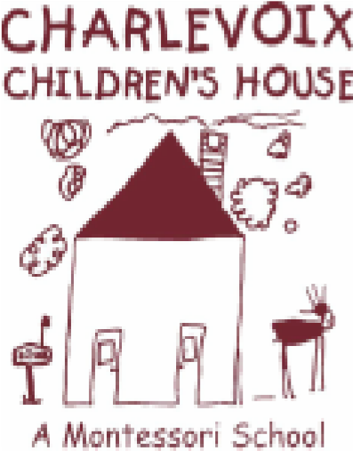
Minutes from:
Charlevoix Children’s House, Inc.
Executive Board Meeting
*Final Edition
Date: Monday, December 9th, 2019

Time: 6:00 pm

Location: Charlevoix Public Library, Armstrong Room
Board Members:
Present: Seth Arnold, Linda Zerby, Amanda Evans, Molly Vargas

Absent: Chris Matye, Jill Kline, Dianne Dreyer

Others Present: N/A
Proceedings:
- Meeting called to order at 6:03 p.m. by President, Seth Arnold
- November meeting minutes approved by Arnold and seconded by Zerby
- Matters for Decision
3.1
Action Item:
3.2
Action Item:

  - Treasurer’s Report: Jill Kline n/a, absent

4.2 President’s Report/Building, Maintenance & Playground: Seth Arnold no report

4.3. Vice President’s/Website& Marketing Report: Chris Matye, n/a
  - Directress Report: Molly Vargas, Directress
      - Christmas program update
  - Fundraising & Grant: Amanda Evans
      - Awaiting final bills for bar/catering for fright night
      - Need graphic design bill paid for fright night
      - Giving Tuesday update: 1,320.00 current total
      - Facebook birthday fundraiser need final total of amount raised
      - Long Day Coffee fundraiser advertising
  - Social & Volunteer/Fundraising & Grant: Linda Zerby
    - Cottage pottery fundraiser follow up on amount raised
    - Charlevoix Community fundraiser check f/u
5.1 New Business:
5.2. Old Business:
Announcements: Next Board of Director’s meeting will be held on Monday, January 13th at 6:00 pm at the Charlevoix Public Library in the Armstrong Room

Meeting adjourned at 6:23 p.m by Seth Arnold.
Meeting Minutes submitted by Secretary, Linda Zerby

