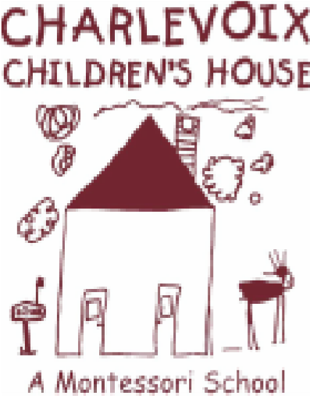
Minutes from:
Charlevoix Children’s House, Inc.
Executive Board Meeting
*APPROVED
Date: May 13th, 2019

Time: 6:00 pm

Location: Charlevoix Public Library, Armstrong Room
Board Members:
Present: Seth Arnold, Linda Zerby, Amanda Evans, Molly Vargas, Jill Kline
Absent: Dianne Dreyer, Chris Matye
Others Present: N/A
Proceedings:
- Meeting called to order at 6:04 p.m. by President, Seth Arnold
- April meeting minutes approved by Arnold and seconded by Zerby
- Matters for Decision
  - 2019-2020 Enrollment update-currently 19 students enrolled
  - Ellsworth Contract-payment has been submitted but check not yet cleared and will be followed up on by treasurer Kline
  - Treasurer’s Report: Jill Kline
Kline gave brief report regarding financials and will email an updated copy as soon as possible once she collaborates with Ms Dreyer. Will also update regarding Ellsworth Contract payment as well as final fundraising balances including long day coffee fundraiser.

  - President’s Report/Building, Maintenance & Playground: Seth Arnold
Seth will be signing updated tax returns this week. He emailed landscapers regarding spring cleanup which will hopefully be done before trik a thon this Thursday the 16th, however if not we may need volunteers to help clean up front of school prior to trik a thon. This will be mentioned in this weeks newsletter

4.3. Vice President’s/Website& Marketing Report: Chris Matye
No report
  - Directress Report: Molly Vargas, Directress
Updated enrollment which includes 19 children with possible a full time or part time family filling final spot.
  - Fundraising & Grant: Amanda Evans
Update regarding fright night fundraiser and collecting auction items, plan is to start earlier with auction collection, ideally by next month. Plan is to contact returning families to get them involved early.
Discussed possible new auctioneer for 2019 Fright night-evans is awaiting replys/quotes
Catering, bartending and DJ will be provided by same vendors as last year.
Discussion ensued regarding the renaming of sponsor levels, currently there is Presenting as well as Table sponsor, which has raised some confusion. Decision was made to create a new category titled “Corporate Sponsors” who are companies providing a significant discount to our organization, including castle farms, pigs, DJ etc. Corporate sponsors will receive more advertising including on the fright night flyers. Companies may also become a Corporate Sponsor by a donation of $2000.00, which will not include tickets to the event, but will receive the same press coverage as the vendors providing discounted services. Presenting Sponsor as well as table sponsor will be renamed, still open to suggestions, but thinking “Corporate partner” and “Corporate Friend” respectively.
Discussed raising Presenting Sponsor (Now called Corporate Partner) from 600.00 to 800.00 and keeping Table Sponsor (Now Corporate Friend) at 250.00.
We will plan on posting to social media individual sponsors donations as they are received.
Ticket Prices will be kept at 60.00 a piece
We will plan to advertise that fright night will be back in the original location of Knights Castle and plan to seat 10 per table.
  - Social & Volunteer/Fundraising & Grant: Linda Zerby
Will be looking into online auction items, specifically Disney community fundraiser that will provide park hopper tickets for our silent auction, ideas include a spring clean up, canned food drive etc.
5.1 New Business:
5.2. Old Business:
Announcements: Next Board of Director’s meeting will be held on Monday, June 10th at 6:00 pm at the Charlevoix Public Library in the Armstrong Room

Meeting adjourned at 7:56 p.m by Seth Arnold
Meeting Minutes submitted by Secretary, Linda Zerby

